Bahria University,

Karachi Campus



Course: CSL 220 Database management systems Lab

Term: Spring 2022, Class: BSE- 4(B)

Submitted By:

Abdul Quddos 69984

(Name) (Reg. No.)

Submitted To:

Mam Laraib Siddique/Engr. Ayesha Khan

Signed Remarks: Score:

INDEX

|  |  |  |  |  |
| --- | --- | --- | --- | --- |
| SNO | DATE | LAB NO | LAB OBJECTIVE | SIGN |
| 1 | 8/3/22 | 1 | Intro To DBMS |  |
|  |  |  |  |  |
|  |  |  |  |  |
|  |  |  |  |  |
|  |  |  |  |  |
|  |  |  |  |  |
|  |  |  |  |  |
|  |  |  |  |  |
|  |  |  |  |  |
|  |  |  |  |  |
|  |  |  |  |  |
|  |  |  |  |  |
|  |  |  |  |  |
|  |  |  |  |  |
|  |  |  |  |  |
|  |  |  |  |  |
|  |  |  |  |  |
|  |  |  |  |  |
|  |  |  |  |  |
|  |  |  |  |  |

Bahria University,

Karachi Campus



LAB EXPERIMENT NO.

1

LIST OF TASKS

|  |  |
| --- | --- |
| TASK NO | OBJECTIVE |
| 1 | Get Order id, Product id, Unit price from Order Details. |
| 2 | Find Title of employee Nancy. |
| 3 | Display data of all employees those working as Sales Representative from London |
| 4 | Display product name whose unit price are greater than 90$ |
| 5 | Write a query to get current Product list (Product ID and name). |
| 6 | Fetch data of customers where country is "Germany" AND city must be "Berlin" OR "München" (use parenthesis to form complex expressions) |
| 7 | Fetch data of customers from all countries except Germany and USA |
| 8 | Fetch Discontinued products who’s price is greater than 20 |
|  |  |
|  |  |

Submitted On:

(Date: 8/3/22)

**LAB # 01**

**Task # 1: Get Order id, Product id, Unit price from Order Details.**

**Code:**

select OrderID,ProductID,UnitPrice from [Order Details]

**Output:**

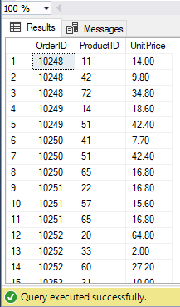

**Task # 2: Find Title of employee Nancy**.

**Code:**

select FirstName, Title from Employees where FirstName='Nancy'

**Output:**

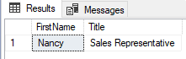

**Task # 3: Get the price of an order (by multiplying unit price by quantity).**

**Code:**

**Output:**

**Task # 4:** **Display all cities that employees belong to but don’t allow repetition**.

**Code:**

select distinct City from Employees

**Output:**

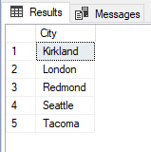

**Task # 5: Find complete name of all employees.**

**Code:**

SELECT FirstName,LastName FROM Employees

**Output:**

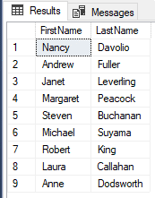

**Task # 6: Display data of all employees those working as Sales Representative**

**Code:**

select FirstName,LastName,Title from Employees where Title='Sales Representative'

**Output:**

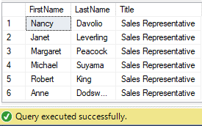

**Task # 7: Display complete name of employees those lives in London.**

**Code:**

select FirstName,LastName,City from Employees where City='London'

**Output:**

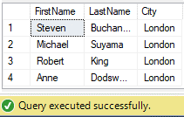

**Task # 8: Display product name whose unit price are greater than 90$.**

**Code:**

select ProductName,UnitPrice from Products where UnitPrice>90

**Output:**

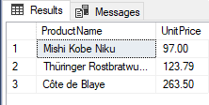

**Task # 9: List the name of all employees whose first name starts with the letter ‘A’.**

**Code:**

select FirstName from Employees where FirstName like 'A%'

**Output:**

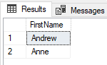

**Task # 10: In Customer table, display all cities that ends with the letter ‘a’.**

**Code:**

select City from Customers where City like '%a'

**Output:**

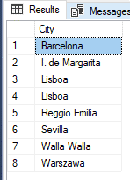

**Task # 11: Display names of all employees whose name contain ‘an’.**

**Code:**

select FirstName from Employees where FirstName like '%an%'

**Output:**

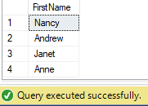

**Task # 12: Display all the orders where unit price lies in the range of 10$ to 40$.**

**Code:**

select * from [Order Details] where UnitPrice Between 10 and 40

**Output:**

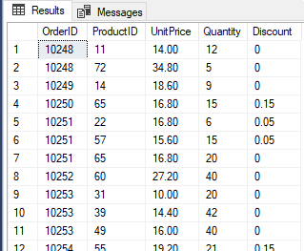

**Task # 13:**

**Code:**

select CompanyName,Region from Customers where Region is null

**Output:**

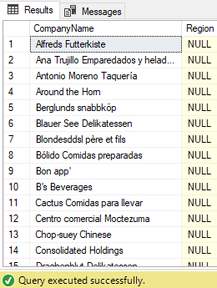

**Task # 14: Write a query to list employees who live in London, Seattle or Redmond**

**Code:**

select EmployeeID, TitleOfCourtesy, FirstName, City, Country from Employees where City in ('London','Seattle','Redmond')

**Output:**

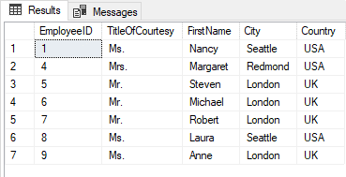

**Task # 15: Write a query to list employees whose address contains 3 numbers in its start.**

**Code:**

select FirstName, LastName, Title, [Address] from Employees where [Address] like '___ %'

**Output:**

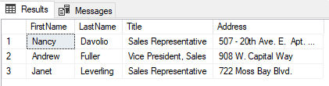

**Task # 16: Write a query to list employees whose address does not contain Rd.**

**Code:**

select FirstName, LastName, Title, [Address] from Employees where [Address] not like '%Rd.'

**Output:**

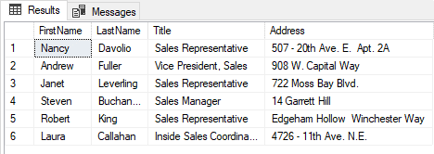

**Task # 17: Write a query to list all those employees whose TitleofCourtesy does not starts with M**.

**Code:**

select TitleOfCourtesy, FirstName,LastName from Employees where TitleOfCourtesy not like 'M%'

**Output:**

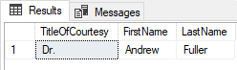

**Task # 18: List order details whose ShipRegion is not Null.**

**Code:**

select CustomerID,ShipName,ShipAddress,ShipRegion from Orders where ShipRegion is not null

**Output:**

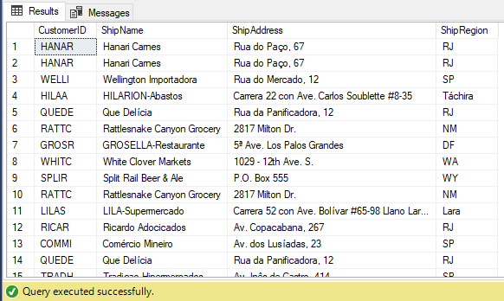

**Task # 19: List all products where UnitPrice is between 10 and 15 and QuantityPerUnit contains “bottles”**

**Code:**

select ProductID, ProductName, QuantityPerUnit, UnitPrice from Products where UnitPrice between 10 and 15 and QuantityPerUnit like '%bottles'

**Output:**

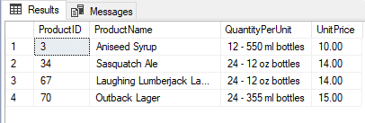

**Task # 20:** **List all products where UnitPrice is not in 10,12,15,17 or 19**

**Code:**

select * from Products where UnitPrice not in (10,12,15,17,19)

**Output:**

